

**Stenography Lab**

# Objectives

**The city has been set for the exchange of the product. However, before you could get the information, your contact was compromised. You have nothing left but an email with the cryptic message “locate a line of three stars and that shall point the way” and a file attachment (included in the zip file**). **If you know your contact, and you do, you know your contact is lazy and will not hide the information too well. It is most likely dropped in the file somewhere in byte sized chunks.**

# Discussion and Deliverable

Bitmap has the following format. Information about the file is located in the first 54 bytes of the file. Then after 54 bytes, pixel information is listed for each color value. The city name is hidden somewhere in the pixel data. 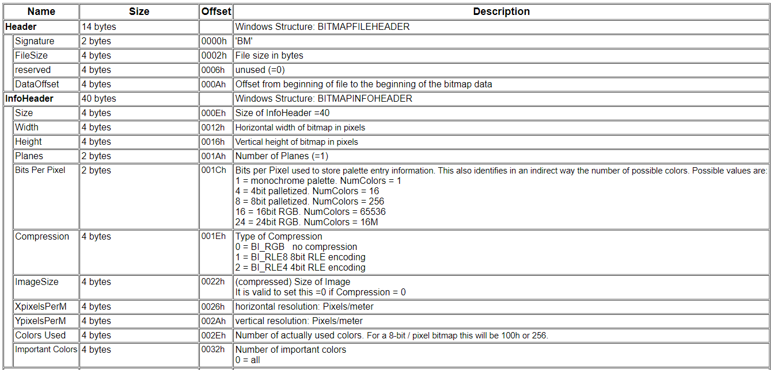 The deliverable of this lab falls in three parts. First part is deciphering the bitmap format and answering the following questions. The second part is allocating space in heap and loading the file information into the space allocated. The third part is shifting through the file contents to find the rendezvous city.

**Part 1:** Create space in the data section for the header information. Open the file and load the information into the .data section (look at syscall 13 and 14. There is also an examples at the bottom of the syscall table in MARS Mips). Comment each section in the .asm file to explain what you’re doing. Look through the .data memory to answer the following questions:

1. What is the first two bytes of the bmp file?
2. What is the file size? (note: bitmap format is in little endian) Take a screenshot of the .data memory field(s) and highlight this information
3. What is the Bits Per Pixel value for this file? Take a screenshot of the .data memory field(s) and highlight this information.

**Part 2:** Using the information from part 1, allocate space on heap using the size information (syscall 9) and open the rest of the file onto the heap. Comment the asm file with explanations on what the code is doing.

**Part 3:** Shift through the information on the heap to find the clue given. You can try to figure it out yourself or unhighlight the following to see how you can find the city: The city will follow three asterisks. Again, comment the .asm file with explanations on what you’re doing.

Zip your asm file and this document with part 1 filled out and turn it into FSO.

# RUBRIC (Total 100 Points)

|  |  |
| --- | --- |
| Points | Description |
| 30 | Part 1 |
| 20 | Part 2 |
| 30 | Part 3 |
| 20 | Clear comments |

# FSO SUBMISSIONS

Your project source code must be zipped up and submitted (turned-in) to FSO. Labs do not require being checked off by the Lab Specialist or Course Director before submission. However, if you complete your lab before the lab period ends, then you may request check-off to leave early.

**NOTE**: Unless otherwise stated by the course director, labs submitted after due date are considered late.